Ideation Phase
Empathize & Discover

Date | 31 January 2025
Team ID | LTVIP2026TMIDS42531
Project Name | ShopEZ:One-Stop Shop for Online Purchases
Maximum Marks | 4 Marks

Empathy Map Canvas:

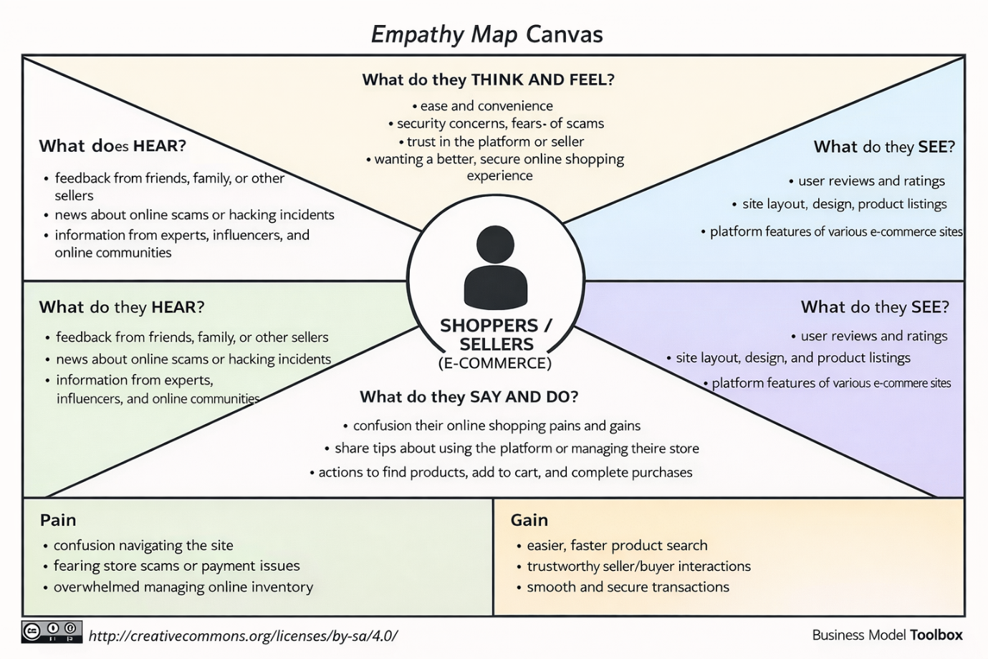

Reference: https://www.mural.co/templates/empathy-map-canvas

